Semi groups
Semigroups
- Part I: Semigroup and Monoid
  - Binary operations and their properties
  - Semigroup and monoid
  - Isomorphism and homomorphism
- Part II: Fundamental Homomorphism Theorem
  - Congruence relation
  - Quotient semigroup
  - Natural homomorphism
  - Fundamental homomorphism theorem for semigroup
Binary Operation
- Function ƒ:An→B is called an n-nary operation from A to B.
  - Binary operation: ƒ:A×A→B
  - An example: a new operation “*” defined on the set of real number, using common arithmatic operations:
x*y = x+y-ab
Note: 2*3 = -1； 0.5*0.7 = 0.85
- An operation is a function, so the following are not operations:
  - Let A=R, define * on A: a*b as a/b
  - Let A=Z, define * on A: a*b as a number less than a,b
Closedness of Operations
- For any operation ƒ:An→B, if B⊆A, then it is said that A is closed with respect to ƒ. Or, we say that ƒ is closed on A.
(What does the operation table of a closed operation look like?)

- Example:
  - Set A={1,2,3,…,10}, gcd is closed, but lcm is not.
  - Discuss the closeness of common addition on the following set:
    - {n | there exists a positive integer k, such that 16|nk}
    - {n | 9 divides 21n}
- Assuming A⊂B，if A is closed with respect to *, what about B? And if B is closed with respect to *, what about A?
- Algebraic SystemDefinition:
  - A nonempty set S (no limitation about its elements)
  - One or more operations (binary operations in most cases)
  - S is closed with respect to these operations
- Denotation: (S, °)
- Example:
  - (Z, +), here, Z is the set of integers and + is arithmatic addition
Operation Table
Operation table can be used to define unary or binary operations on a finite set (usually only with several elements)
Properties of Binary Operations
- Associativity
  - Operation “⃘” defined on the set A is associative if and only if:
For any x, y, z ∈A, (x°y) ° z = x °(y ° z)
- Commutativity
  - Operation “°” defined on the set A is commutative if and only if:
For any x, y ∈A, x ° y = y ° x
- Idempotence
  - Operation “°” defined on the set A is idempotent if and only if:
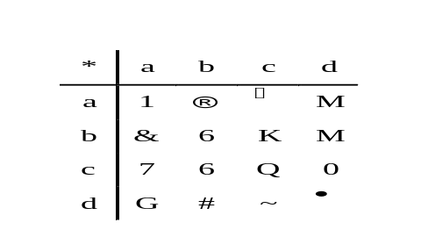 For any x ∈A, x°x =x

Identity of an Algebraic System
- For arithmatic multiplication on the set of real number, there is a specific real number 1，satisfying that for any real number x, 1∙x=x∙1=x
- An element e is called the identity element of an algebraic system (S, °) if and only if :
For any x∈S, e ° x=x ° e=x。
- Denotation: 1S, or simply 1, but remember that it is not that “1”.
- It is not that every algebraic system has its identity element.
An Example about Coding
- Given a alphabet A={0,1}, A* is the set of string of length n on A.
- Define a binary operation ⊕ on A* as follows:
  - For any x,y∈A*, x⊕y is a binary string of length n, in which, the ith bit is 1 if and only if the corresponding bits in x and y are different. (i=0,1,…,n-1)
- (A*, ⊕) is an algebraic system
- Satisfied properties: association, commutation, identity
A System with Specified Properties
Let (A,*) is a system satisfying idempotent, commutative and associative properties. Define a relation ≤ on A by a≤b iff. a=a*b
- Then (A,≤) is a poset, and for all a,b in A, GLB(a,b)=a*b
  - Reflexivity: since a*a=a, so, a≤a for all a in A
  - Antisymmetry: if a≤b, b≤a, then a=a*b, and b=b*a, but a*b=b*a, so, a=b
  - Transitivity: if a≤b, b≤c, then a=a*b, b=b*c, so, a=a*(b*c)=(a*b)*c=a*c, so, a≤c
  - GLB:
    - a*b is a lower bound of {a,b}: (a*b)=(a*a)*b=(a*b)*a, and similarly, (a*b)=a*(b*b)=(a*b)*b
    - a*b is GLB: if c≤a, and c≤b, then c=c*a and c=c*b, so, c=(c*a)*b=c*(a*b)
Axiomatic System
- Abstract system: too general
- Concrete system: too many

- Abstract algebra as a branch of modern mathematics: axiomatic system
  - Axioms of the system: usually, one or more of the properties discussed above
Semigroup
- Axiom of semigroup
  - Association
- An example ({1,2},*), * defined as follows:
For any x,y∈{1,2}, x*y=y
Proof: it should be proved that for any x,y,z in {1,2}, (x*y)*z = x* (y*z)
Note: if checking by operation table, we have to check as many as 8 equations.

Generalized Associative Law
- If a1, a2,...an, n≥3, are arbitrary elements of a semigroup, then all products of the elements a1, a2,...an that can be formed by inserting meaningful parentheses arbitrarily are equal.
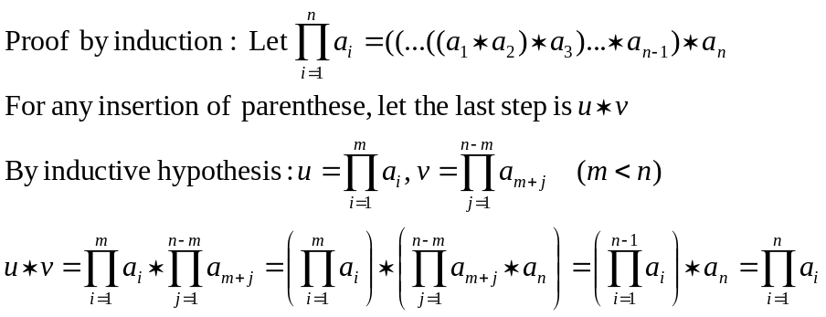

Power
- If operation “°” is associative, then we can define the exponential function as follows:
x1 = x
xn+1 = xn ° x (n is positive integer)
- In addition, if “°” has the identity, then:
x0 = e （e is the identity）
xn+1 = xn ° x (n is nonnegative integer)
- xn ° xm= xn+m
- (xn)m= xnm
Several Examples of Semigroup
- Example 1: (A,*) is a semigroupm. For any a,b, if a≠b, then a*b ≠b*a, show:
  - (1) a*a = a
Note: (a*a)*a = a*(a*a)
  - (2) a*b*a = a
  - (3) a*b*c = a*c
- Example 2: (A,*) is a semigroup. There exists an element a in A, such that, for any x in A, there exist u,v, such that a*u=v*a=x. Prove that A has an identity.
  - Sketch of proof: for a itself, there are also ua,va, such that,
a*ua =a; va*a=a. Then for any x, x*ua=(vx*a)* ua=vx*a=x, which means that ua is a right identity. Similarly, we can prove that va is also left identity.
Monoid
- Axioms of the system
  - Association
  - Identity
- Examples
  - P(S), where S is a set, together with the operation union or intersection are both commutative monoids
  - The set of all functions f :S→S, denoted as SS, together with the operation of composition is a monoid
Subsystems
- Subsemigroup
  - Let (S,*) be a semigroup and let T⊆S. If T is closed under the operation *, then (T,*), which is obviously a semigroup itself, is called a subsemigroup of (S,*)
  - (Z,+), (Q,+) are both subsemigroups of (R,+)
- Submonoid
  - Let (S,*) be a monoid with identity e, and let T⊆S. If T is closed under the operation * and e∈T, then (T,*), which is obviously a monoid itself, is called a submonoid of (S,*)
Examples of Subsystem
An Example:
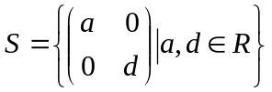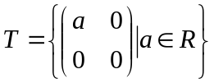

- Let “*” be matric multiplication, then both (S,*) and (T,*) are both monoids. T is a subsemigroup of S, but it is not a submonoid(why?).
Systems that look alike
- 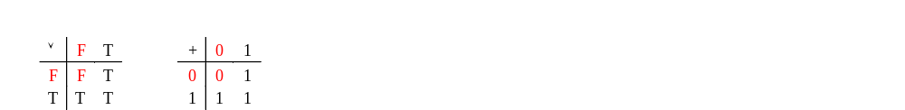Logical or” and ““Boolean sum”

Note: if the signs and their meaning are ignored, the two tables are same
Isomorphism

- Semigroup (S, °) and (T,*) are isomorphic (S≅T) if and only if:
There exist a one-to-one correspondence f: S→T, such that: (f is called an isomophism)
For any x,y∈S, f (x ° y) = f (x) * f (y)
- Isomorphism is an equivalence relation.
  - Reflexibility: the identity function is a one-to-one correspondence.
  - Symmetry: inverse of a one-to-one correspondence is also a one-to-one correspondence.
  - Transitivity: the composition of two one-to-one correspondence is also a one-to-one correspondence.

Show Isomorphism of Two Systems
- Basic approach: find a one-to-to correspondence and check it for the requirements for the isomorphism
- Examples
  - “logical OR” semigroup ({F,T},∨) and Boolean sum semigroup ({0,1},+)
isomorphism f : {F,T}→{0,1}: f(F)=0, f(T)=1

  - Positive real number multiplication semigroup (R+,•) and real number addition semigroup (R,+)
isomorphism f: R+→R: f(x)=ln x
Note: f(x)=lg x is another isomorphism
How to Negate isomorphism
- To prove semigroups (S, °) and (T,*) are not isomorphic to each other, you must prove that any functions from (S, °) to (T,*) cannot be an isomorphism between them.
  - Example:
  - nonzero rational number multiplication semigroup (Q-{0},•) and rational number addition semigroup (Q,+) are not isomorphic to each other
If there exists an isomorphism f : Q-{0}→Q,
then f(1)=0 (otherwise, f(1•x)≠f(1)+ f(x))
However, f(-1)+f(-1)= f((-1)•(-1))=f(1)=0
So, f(-1)=f(1)，f is not one-to-one, contradiction.
Homomorphism
- Semigroup (S, °) and (T,*) are homomorphic, denoted as (S~T) if and only if:
There exists a function f: S→T such that:
for any x,y∈S, f (x ° y) = f (x) * f (y)
- If f is also onto, then T is a homomorphic image of G1.
- Note: isomorphism is a special case of homomorphism
- Example: integer addition semigroup (Z,+) and mod-3 addition semigroup (Z3,+3)
  - homomorphism: f : Z→Z3, f(3k+r)=r
Isomorphism and Homomorphism: Generalized
- The discussion about isomorphism and homomorphism can be generalized to general algebraic systems
  - Algebraic systems (G1, °) and (G2,*) are isomorphic if and only if:
there exists a one-to-one correspondence f: G1→G2, such that:
for any x,y∈G1, f (x ° y) = f (x) * f (y)
  - Algebraic systems (G1, °) and (G2,*) homomorphic if and only if:
there exists a function f: G1→G2, such that:
for any x,y∈G1, f (x ° y) = f (x) * f (y)
And if f is onto, then G2 is a homomorphic image of G1.
Homomorphic Image and System Properties
- Association
  - Assuming that f: G1→G2 is a homomorphism, and G2 is a homomorphic image of G1, then, if G1 is associative, so is G2, i.e. for any x,y,z∈G2,(x ° y) ° z=x °(y ° z)
  - Proof: for any x’,y’,z’∈G2, since f is onto, there must be x,y,z∈G1, such that f(x)=x’, f(y)=y’, f(z)=z’. So, (x’*y’)*z’ = (f(x)* f(y))* f(z) = f(x ° y) * f(z) = f((x ° y) ° z) = f(x °(y ° z)) = f(x)* (f(y)* f(z)) = x’*(y’*z’)

- Same discussion applies for commutation.
Homomorphic Image and System Properties
- Identity
  - Assuming that f: G1→G2 is a homomorphism, and G2 is a homomorphic image of G1, then, if G1 has an identity e, so does G2, i.e. there exists e’ in G2, such that for any x∈G2, (x*e)=(e*x)=x
  - Proof: for any x’∈G2, since f is onto, there must be x∈G1, such that f(x)=x’. Let f(e)=e’, then, (x’*f(e)) = (f(x)* f(e))= f(x°e) = f(x) = x’. (f(e)*x)=x can be proved similarly.
Note that f(e) is in G2, so, it is the identity of G2.
Holding the System Properties

G
1

g
:

onto
G
2

f
:

function

h
:
one-to-one correspondence
f (G₁)
Homomorphism and Subsystem
- Let f be a homomorphism from a semigroup (S, °) to a semigroup (T,*). If S’ is a subsemigroup of (S, °), then
f(S’)={t∈T|t=f(s) for some s∈S’}
the image of S’ under f, is a subsemigroup of (T,*)
- Proof
  - Closedness of f(S’)
  - Associativity hold on f(S’)
Products of Semigroup
- If (S,°) and (T,*) are semigroups, then (S×T, ⊗) is also a semigroup, called product of semigroups (S,°) and (T,*), where ⊗ is defined by (s1,t1)⊗(s2,t2)=(s1°s2, t1*t2)
- Proof
  - Obviously, (S×T, ⊗) is a algebraic system
  - [Associative] ((s1,t1)⊗(s2,t2))⊗(s3,t3) = ((s1°s2) °s3, (t1*t2)*t3) = (s1°(s2°s3), t1*(t2*t3)) = (s1,t1)⊗((s2,t2)⊗(s3,t3))
Products of Monoid
- If (S,°) and (T,*) are monoids, with identities es and et, then (S×T, ⊗) is also a monoid , called product of monoids (S,°) and (T,*), where ⊗ is defined by (s1,t1)⊗(s2,t2)=(s1°s2, t1*t2). And the identity of (S×T, ⊗) is (eS,eT)
- Proof
  - Obviously, (S×T, ⊗) is a algebraic system
  - [Associative] ((s1,t1)⊗(s2,t2))⊗(s3,t3) = ((s1°s2) °s3, (t1*t2)*t3) = (s1°(s2°s3), t1*(t2*t3)) = (s1,t1)⊗((s2,t2)⊗(s3,t3))
  - [Identity] For any s∈S, t∈T, (s,t)⊗(es,et) = (s°eS, t*eT) = (s,t); same with (es,et)⊗(s,t)
Congruence
- An example: defining a relation on the set of integer as: a≡b (mod 3) iff. |a-b|/3 is an integer
  - It is an equivalence
  - equivalence class: π1={…-3,0,3,6,9,…}
π2={…-2,1,4,7,10,…}
π3={…-1,2,5,8,11,…}
- Note: if x1,x2 are in the same class, and y1,y2 in same class, then x1+y1 and x2+y2 are in the same class.
- Generalized: An equivalence relation R on the semigroup (S,*) is called a congruence relation if
aRa’ and bRb’ imply (a*b)R(a’*b’)
Congruence on a Free Semigroup
- Let A={0,1}. A* is the set of all finite sequence of elements of A. Then, A* with the operation catenation is a semigroup, called free semigroup generated by A.
- Define relation R on A* as following:
αRβ iff. α and β have the same number of 1’s
- R is an equivalence
- R is a congruence relation
  - Suppose α1 and α2 have the same number of 1’s, and β1 and β2 have the same number of 1’s. Note the number of the number of 1’s in βα is the sum of that in α and β , so, α1β1 and α2β2 have the same number of 1’s
All Equivalences are not Congruence
- (Z,+) is a semigroup, where “+” is common addition operation.
- Given a function f(x)=x2-x-2=(x+1)(x-2), a relation on Z is defined as following:
aRb if and only if f(a)=f(b)
- R is an equivalence
- R is not a congruence relation
  - Note that (-1)R2, and, (-2)R3, but not (-3)R5
Quotient Semigroup
- Let R is a congruence relation on the semigroup (S,*). S/R is the quotient set, i.e. the set of all equivalence classed.
- Define an operation ⊗ from S/R×S/R to S/R as [a]⊗[b]=[a*b]. Note the operation is well-defined because R is a congruence relation.
  - Suppose ([a],[b])=([a’],[b’]), then aRa’, bRb’, by the definition of congruence relation, a*b=a’*b’, so ⊗ is a well-defined function from S/R×S/R to S/R
- (S/R,⊗) is a semigroup, called quotient semigroup
Natural Homomorphism
- Any semigroup and its corresponding quotient semigroup are onto homomorphic
- Let (S/R,⊗) is the corresponding quotient semigroup of semigroup (S,*), define a function fR:S→S/R as following:
fR(a)=[a]
  - By the definition of equivalence class, fR is a well-defined onto function from S to S/R.
  - For any a,b in S, fR(a*b)=[a*b]=[a]⊗[b]=fR(a)⊗fR(b), which means fR is a homomorphism

A Congruence Relation Determined by a Homomorphism
(S,°)
(T,*)
Two semigroups
f
f is a homomorphism
a
b
R defined on S
a₁
b₁
f(a)=f(a₁)
f(b)=f(b₁)
It is easy to prove that R is an equivalence.
R is a congruence relation:
f(a°b) = f(a)*f(b)
f(a_{1°}b₁) = f(a₁)*f(b₁)
However: f(a)*f(b) = f(a₁)*f(b₁)
Which means:
f(a°b) = f(a_{1°}b₁)
That is: (a°b)R(a₁*b₁)
Fundamental Homomorphism Theorem
(S,°)
(T,*)
Homomorphism
f
S
T
/
Quotient
semigroup
f_{R}
Natural
homomorphism
?
Define g: S/T→T as following:
g([a])=f(a) for any [a]∈S/T
1. g is a function: that is for any other
element a’ in [a], g[a’]=f[a]
2. g is one-to-one: all element a having the same value of f(a) are in one equivalence class.
3. g is onto: for any b∈T, there is some a∈S, such that f(a)=b, then g[a]=b.
4. g is an isomorphism:
g([a]⊗[b])=g([a°b])=f(a°b)=f(a)*f(b) =g([a])*g([b])
An Example of Free Semigroup
(A*,°)
(N,+)
Homomorphism
f
A*
/
Quotient
semigroup
f_{R}
Natural
homomorphism
g
A={0,1}
Λ∈A*
f: A*→N: f(α)=the number of 1’s in α
Define relation R on A* as following:
αRβ iff. f(α)=f(β)
Then, by the fundamental homomorphism theorem:
A*/N ≅ N,
and the ismorphism is:
g[α]=the number of 1’s in α. and f = g°f_{R}
N

